**Wear Solutions for Forestry and Fishing Industries**

In demanding sectors like forestry and fishing, wear and tear are constant challenges that impact equipment and productivity. Implementing effective wear solutions is vital to ensure smooth operations and maintain efficiency.

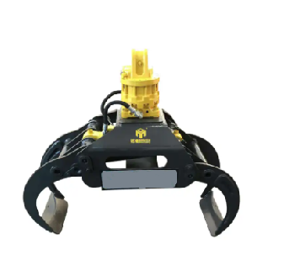**Enhancing Log Forks Performance**

Log forks are versatile tools that handle critical tasks such as loading, sorting, and hauling palletized loads and lumber. The challenges they face require materials of the highest strength and durability. The high-performance Abrasion Resistance steel has emerged as a game-changer for log fork arms. This innovative steel significantly reduces the weight of the arms while simultaneously increasing the payload capacity. This translates to enhanced handling capabilities for heavy items, including sawmill logs, contributing to streamlined operations and improved efficiency.

Benefits of using AR steel in log forks:

1. **Extended service life**: AR steel can extend the service life of log forks by several years. This is because the steel is less likely to wear away than regular steel, so it can last longer and lift more logs.
2. **Reduced maintenance:** AR steel is less likely to corrode or rust, which means that it requires less maintenance.
3. **Improved efficiency:** AR steel can improve the efficiency of the log forks. This is because the steel is less likely to deform or bend, which means that the forks can operate at a higher speed without the risk of damage.
4. **Reduced downtime:** When a log fork is not in use, it can be stored in a protective environment. This will help to prevent the steel from being exposed to the elements, which can extend its lifespan even further.

**Grade**: AR400 or AR450 steel grades can be used in log forks. These steel grades are strong and durable, and they can withstand the wear and tear of lifting and moving logs.

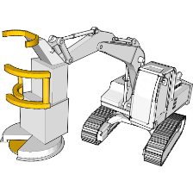**Optimizing Forestry Harvesters**

In the realm of cut-to-length logging, where precision and efficiency are paramount, wear-resistant materials are instrumental in maximizing productivity. By integrating Abrasion Resistant steel plates, forestry harvesters can maintain their cutting-edge performance over extended periods. The wear-resistant properties of this steel translate to prolonged sharpness and durability of delimbing knives and engine protection components, ultimately leading to increased operational efficiency.

**Specifically, AR steel can be used in the following parts of forestry harvesters:**

1. **Cutting blades:** The cutting blades are used to cut down trees. They are typically made of high-carbon steel, but the use of AR steel can significantly improve their lifespan. AR steel is more resistant to wear and tear from the friction of the logs, which can help to prevent the blades from becoming dull or damaged.
2. **Conveyor belts:** The conveyor belts are used to transport the logs from the cutting area to the collection area. They are typically made of rubber, but the use of AR steel can improve their durability. AR steel is more resistant to wear and tear from the friction of the logs, which can help to prevent the belts from tearing or breaking.
3. **Chassis:** The chassis is the frame of the forestry harvester. It is typically made of steel, but the use of AR steel can improve its strength and durability. AR steel is more resistant to bending and breaking, which can help to prevent the chassis from becoming damaged in the event of a collision.
4. **Suspension system:** The suspension system is used to absorb the shock of driving over uneven terrain. It is typically made of steel, but the use of AR steel can improve its durability. AR steel is more resistant to bending and breaking, which can help to prevent the suspension system from becoming damaged.

**Benefits of using AR steel in forestry harvesters:**

1. **Extended service life:** AR steel can extend the service life of forestry harvesters by several years. This is because the steel is less likely to wear away than regular steel, so it can last longer and cut more trees.
2. **Reduced maintenance:** AR steel is less likely to corrode or rust, which means that it requires less maintenance.
3. **Improved efficiency:** AR steel can improve the efficiency of the forestry harvesters. This is because the steel is less likely to deform or bend, which means that the harvesters can operate at a higher speed without the risk of damage.
4. **Reduced downtime:** When a forestry harvester is not in use, it can be stored in a protective environment. This will help to prevent the steel from being exposed to the elements, which can extend its lifespan even further.

**Grade:** AR450 or AR500 steel grades can be used in forestry harvesters. These steel grades are even stronger and more durable than AR400 or AR450 steel grades, and they are better suited for applications where the equipment is subjected to heavy loads and stress.

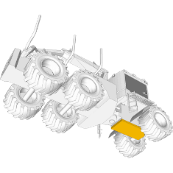**Forestry Forwarders Wear Protection**

Forestry forwarders play a crucial role in hauling logs alongside harvesters, transporting them to designated roadside landings. However, the constant loading and unloading of heavy logs can lead to significant wear, particularly for delimbing knives and engine protection liners. The implementation of Abrasion Resistant steel has proven highly effective in resisting wear in these key areas. Its exceptional durability ensures that forwarders can continue to operate optimally even in rugged environments, reducing maintenance costs and enhancing overall longevity.

Specifically, AR steel can be used in the following parts of forestry forwarders:

1. **Cutting blades:** The cutting blades are used to cut down trees. They are typically made of high-carbon steel, but the use of AR steel can significantly improve their lifespan. AR steel is more resistant to wear and tear from the friction of the logs, which can help to prevent the blades from becoming dull or damaged.
2. **Conveyor belts:** The conveyor belts are typically made of rubber, but the use of AR steel can improve their durability. AR steel is more resistant to wear and tear from the friction of the logs, which can help to prevent the belts from tearing or breaking.
3. **Chassis:** The chassis is typically made of steel, but the use of AR steel can improve its strength and durability. AR steel is more resistant to bending and breaking, which can help to prevent the chassis from becoming damaged in the event of a collision.
4. **Suspension system:** The suspension system is used to absorb the shock of driving over uneven terrain. It is typically made of steel, but the use of AR steel can improve its durability. AR steel is more resistant to bending and breaking, which can help to prevent the suspension system from becoming damaged.
5. **Log grapple:** The log grapple is used to pick up and move logs. It is typically made of steel, but the use of AR steel can improve its durability. AR steel is more resistant to wear and tear from the friction of the logs, which can help to prevent the grapple from becoming damaged.

Benefits of using AR steel in forestry forwarders:

1. **Extended service life:** AR steel can extend the service life of forestry forwarders by several years. This is because the steel is less likely to wear away than regular steel, so it can last longer and transport more logs.
2. **Reduced maintenance:** AR steel is less likely to corrode or rust, which means that it requires less maintenance.
3. **Improved efficiency:** AR steel can improve the efficiency of the forestry forwarders. This is because the steel is less likely to deform or bend, which means that the forwarders can operate at a higher speed without the risk of damage.
4. **Reduced downtime:** When a forestry forwarder is not in use, it can be stored in a protective environment. This will help to prevent the steel from being exposed to the elements, which can extend its lifespan even further.

**Grade:** AR450 or AR500 steel grades can also be used in forestry forwarders. These steel grades are the best choice for applications where the equipment is used to transport heavy loads over rough terrain.

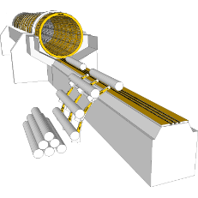**Debarking Drums Wear Solutions**

Debarking drums are prone to wear due to abrasive elements like sand, gravel, and the presence of hard-to-debark wood species. These factors contribute to the gradual deterioration of drum parts. To combat this, Abrasion Resistant steels have emerged as ideal choices for replacing wear strips and drum components. This robust material not only withstand the harsh conditions of debarking but also extend the longevity of the drums, minimizing downtime and maximizing efficiency.

**Specific parts of debarking drums where AR steel can be used:**

1. **Bark removal drums:** The bark removal drums are the main components of the debarking machine. They are typically made of steel, but the use of AR steel can significantly improve their lifespan. AR steel is more resistant to wear and tear from the friction of the logs, which can help to prevent the drums from becoming damaged.
2. **Rotating knives:** The rotating knives are used to remove the bark from the logs. They are typically made of high-carbon steel, but the use of AR steel can improve their durability. AR steel is more resistant to wear and tear from the friction of the logs, which can help to prevent the knives from becoming dull or damaged.
3. **Spikes:** The spikes are used to hold the logs in place while they are being debarked. They are typically made of steel, but the use of AR steel can improve their durability. AR steel is more resistant to wear and tear from the friction of the logs, which can help to prevent the spikes from becoming damaged.

Benefits of using AR steel in debarking drums:

1. **Extended service life:** AR steel can extend the service life of debarking drums by several years. This is because the steel is less likely to wear away than regular steel, so it can last longer and debark more logs.
2. **Reduced maintenance:** AR steel is less likely to corrode or rust, which means that it requires less maintenance.
3. **Improved efficiency:** AR steel can improve the efficiency of the debarking drums. This is because the steel is less likely to deform or bend, which means that the drums can operate at a higher speed without the risk of damage.
4. **Reduced downtime:** When a debarking drum is not in use, it can be stored in a protective environment. This will help to prevent the steel from being exposed to the elements, which can extend its lifespan even further.

**Grade:** AR500 steel grade is the best choice for debarking drums. This steel grade is the strongest and most durable, and it can withstand the wear and tear of removing bark from logs.